Candace Corlett
President
WSL STRATEGIC RETAIL

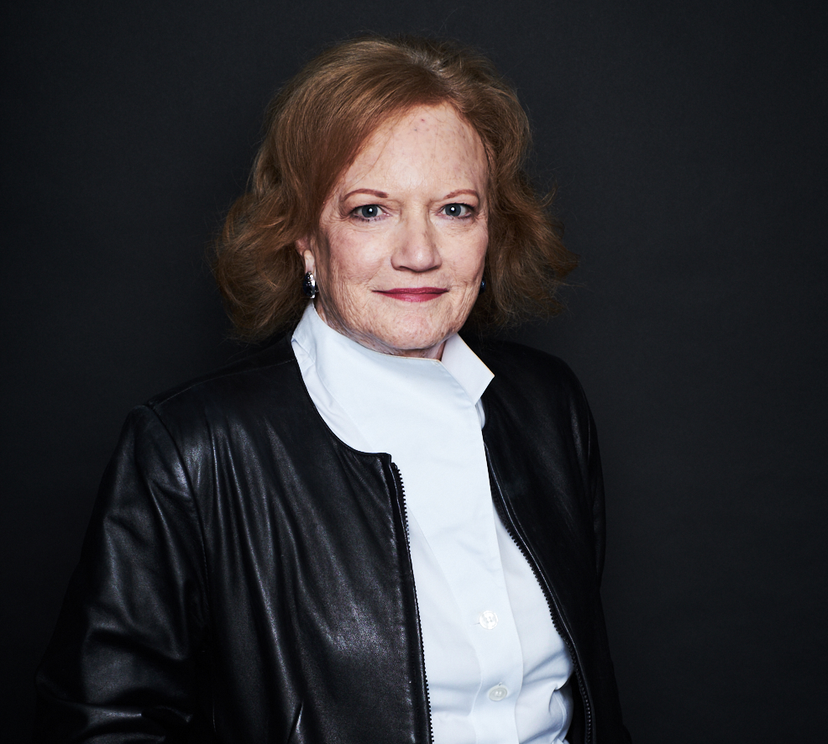
Her credo:
“In the fast-changing retail world don’t ask,
‘What is the answer?’ You need to understand
‘What is the question?’”

Candace Corlett is president of WSL. Established in 1986, WSL is a retail strategy firm that helps manufacturers and retailers bring more shoppers to stores to buy.

The firm is well known for its How America Shops® trend research which predicts changes in Shopping Life® and how those changes will impact business.

Candace has a proven track record in corporate marketing at companies both large and small. She has held management positions in brand marketing and market research at Bristol-Myers Squibb, Revlon, and DEL Laboratories. She joined WSL as a principal in 1995. Her professional background combines the best of classic package goods marketing with an entrepreneur’s spirit.

Her passion is observing Shopping Life®. It is this combination of intuitive observations and survey data that place Candace and her firm at the forefront of shopper insights, preparing their clients for what’s coming next.

Candace is frequently called upon by the media to comment on the state of the retail environment and trends in shopping. She is regularly cited by The Wall Street Journal, The New York Times, Business Week, the Associated Press and appears on CBS, NBC, ABC, CNN, and National Public Radio.

Candace received a Master of Arts degree from The New School University and a degree in Science from St. John’s University.

WSL consults to such industries as retail, beauty, food, beverages, health, home, personal care, entertainment, fashion, publishing, and financial services.

[Updated 2019]

